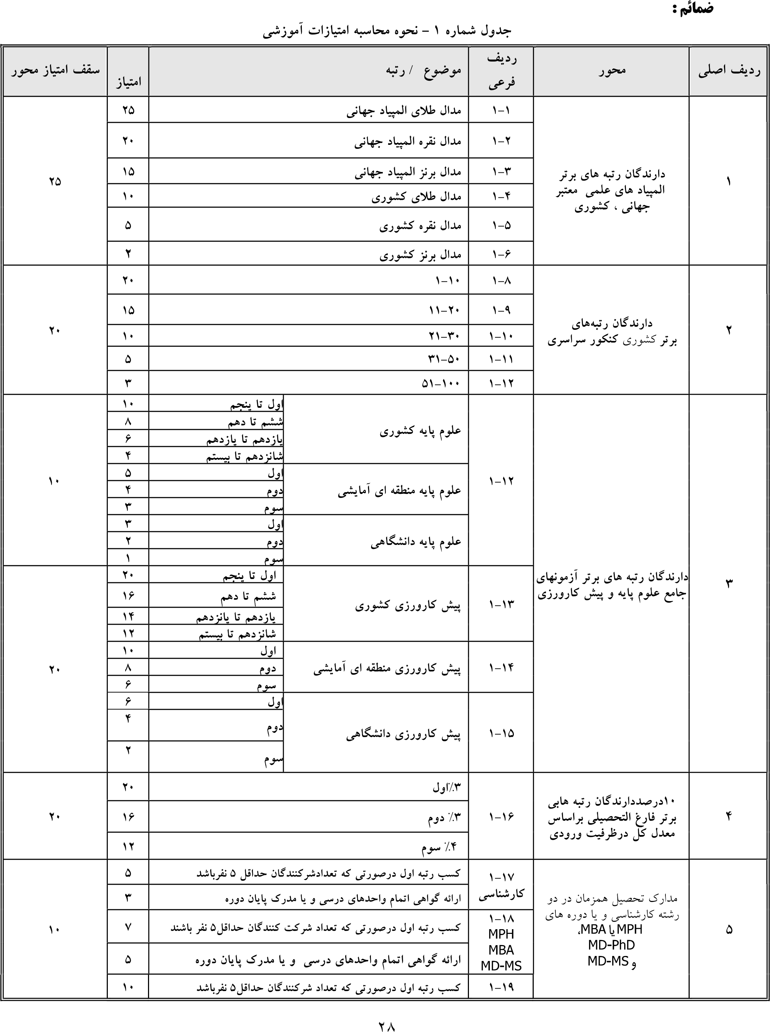

|  |  |  |  |  |  |
| --- | --- | --- | --- | --- | --- |
|  |  |  | MD-PHD |  |  |
|  |
|  |  |  | 20-1  انفرادی |  |  |
|  |  |
|
|  |  |
|  |  |
|  |  | 21-1  گروهی |
|  |  |
|  |  |
|  |  |

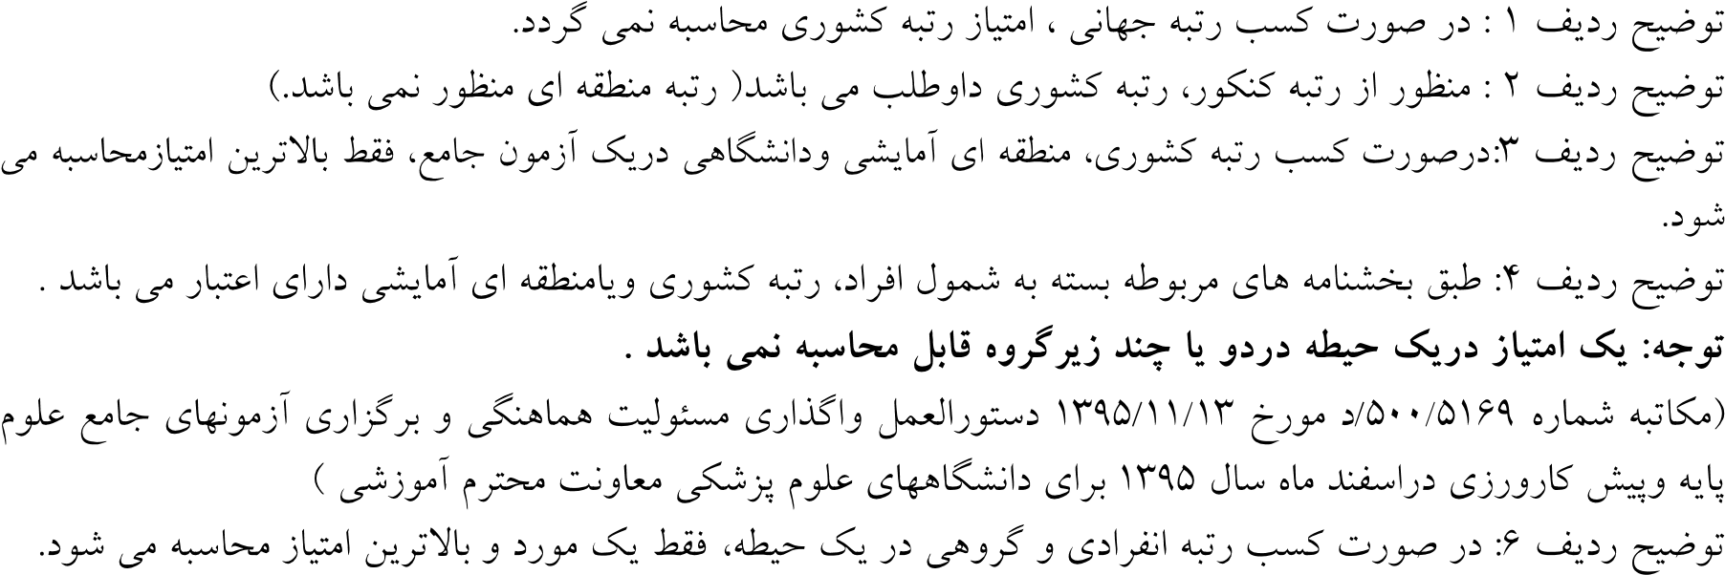

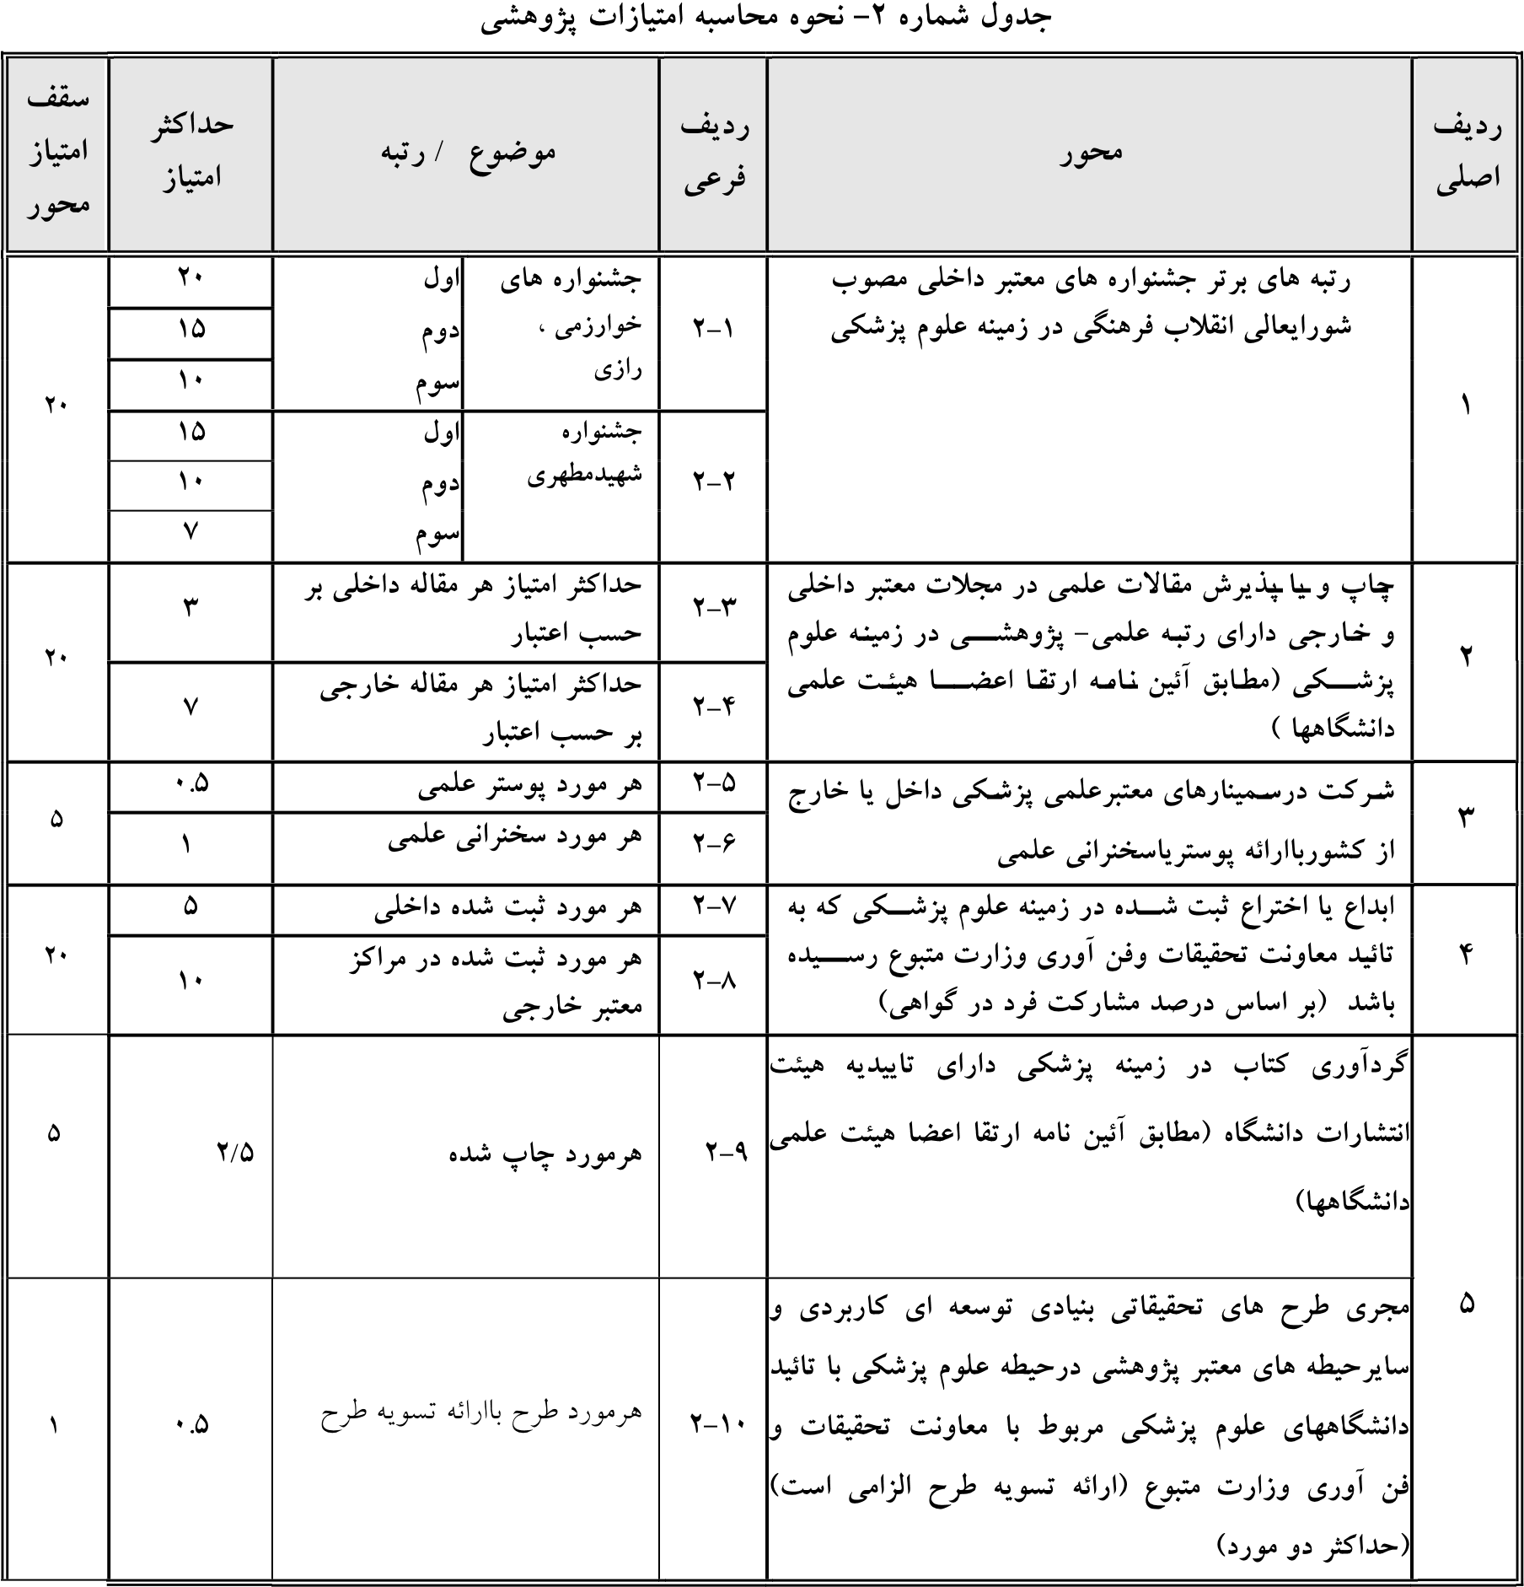

|  |  |  |  |  |  |  |
| --- | --- | --- | --- | --- | --- | --- |
|  |  |  | |  |  |  |
|  |  |  | اول جهانی | 1-3 |  |  |
|  |
|  |  | | 2-3 |
|  |
|  |  | | 3-3 |
|  |
|  |  | | 4-3 |
|  |
|  |  | | 5-3 |
|  |
|  |  | | 6-3 |
|  |
|  |  | | 7-3 |
|  |
|  |  | | 8-3 |
|  |
|  |  | | 9-3 |
|  |



|  |  |  |  |  |  |  |  |  |  |  |  |  |
| --- | --- | --- | --- | --- | --- | --- | --- | --- | --- | --- | --- | --- |
|  |  |  | | | |  |  | | | | |  |
|  |  |  | | | | 1-4 |  | | | | |  |
|  |
|  | آیلتس، 5/6 به بالا و تافل معادل و دیگر زبان های خارجی معادل، |  |  |  | 2-4 |  | | | | |  |
|  | |
|  |
|  |  | | | | 3-4 |  | | | | |  |
|  |
|  |  | | | | 4-4 | کسب مدرک آی تی با مهارت های قابل قبول | | | | |  |
|  |  |  |  |  |  |
|  |  |
|  |  |  | | | | 5-4 |  | | | | |  |
|  |
|  |  | | | | 6-4 |
|  |
|  |  | | | | 7-4 |
|  |
|  |  |  | | | | 8-4 انفرادی |  | | | | |  |
|  |  | | | |
|  |  | | | |  |
|  |  | | | |
|  |  | | | | 9-4 گروهی |
|  |  | | | |
|  |  | | | |  |
|  |  | | | |

